Chapter 4, Problem 2.

Using Fig. 4.70, design a problem to help other students better understand linearity.
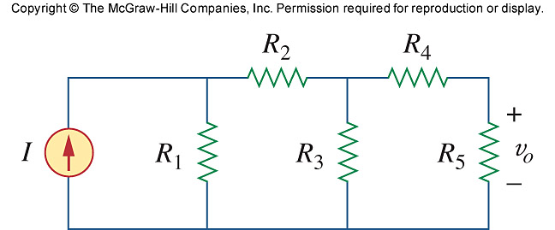

Figure 4.70
For Prob. 4.2.

